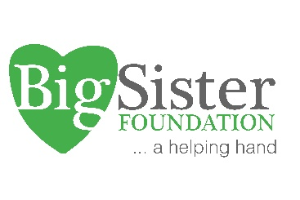

APPLICATIONS FOR BIG SISTER FOUNDATION

2022 COMMUNITY GRANTS ARE NOW OPEN

The Big Sister Foundation invites not-for-profit community organisations within the Georges River, Bayside and Sutherland Shire LGA’s to apply for 2022 grant funding.

Applications are open to local organisations requiring funding for programs and support services that assist women in need and provide opportunities to enable women to make the most of their lives .

Our grant program aim is to maximise the important contribution women make to families and communities, by ensuring local community organisations have funding available to assist them in times of most need

Applications for grants from $5,000 to $100,000 (ex GST) will be accepted.

Applications for grant funding for ongoing programs, up to 3 years, will be considered

The total of the 2022 Community Grants fund is $500,000.

Grants will be awarded in several categories including early intervention programs and crisis services; for delivering education, mentoring and participation activities benefiting local women and girls.

Applications must satisfy at least one of the broad priorities of the Big Sister Foundation 2021-2025:

For women and girls in Southern Sydney

- Health and wellbeing,
- The opportunity for financial wellbeing and security
- The opportunity for participation and empowerment.

- Women's health and wellbeing

Including early-years support for new mothers; women and children experiencing trauma, domestic violence and mental health challenges and associated family support services

- Promoting women's opportunity for financial wellbeing and security
Including
Improving the poor outcomes experienced by women and their children resulting from domestic violence situations. This includes homelessness, financial hardship, isolation and social dislocation.
Improving the poor outcomes experienced by older women who most are likely to experience homelessness.
- Promoting empowerment and participation

Including support for culturally diverse groups and communities including CALD, LGBIT and Indigenous women and girls
Who can apply?
All Incorporated not-for-profit community organisations that are currently registered with the ACNC and approved as not-for-profit bodies by NSW Fair Trading.
Community organisations based, or offering, services in the Georges River, Bayside and Sutherland LGA’s
Grants will not be awarded to fund
- Activities of a commercial nature, however social enterprises will be considered favourably.
- Support of an individual
- Support for political or religious purposes

Application Timelines
The grant round opens November 15th, 2021 and closes Monday, January 31, 2022.

Applicants will be notified of the outcome in early February 2022. The Big Sister Foundation board reserves the right to final decisions .To apply, please read the funding guidelines, and submit your application using the format below. Please ensure all details are included. Late applications will not be accepted.

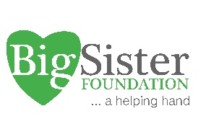
Big Sister Foundation 2022 Community Grants Program
Application Form
Thank you for your interest in the Big Sister Foundation 2022 Community Grants Program. Please use this form as a template for your submission and ensure your submission includes answers to all questions below. Please do not attach separate documents, should we need more information we will contact you. Please also return the signed Application Declaration (page 5)
Please send your application formatted as a pdf file via email to admin@bigsisterfoundation.org.au prior to Monday January 31 2022 (AEST).

Organisational Details
- Organisation Name:
- Organisation ABN
- Organisation Contact details:
Title
First
Name
Last Name
Phone number
Email

- Organisation street address and postal address (if available)

- Organisation website URL and/or applicable social media profile links

- Does your organisation currently receive funding from government sources? Please specify name of department and funded programs

- Please detail type of funding required ie: for a pilot program, implementation of existing program, implementation of new program, research purposes, social enterprise start-up or others

- How much funding in total do you require?

Program Details
Program Outline – please provide a description of your program in 300 - 500 words max and specifically include the following information. Please do not send other attachments, however links are fine.
- Project name and proposed start date
- Primary target group for which your program/service is specifically designed to support.
- Primary problem you are solving
- Primary geographical area/s where it will be delivered
- How many participants do you expect to directly engage?
- Any relevant funding details eg: past funding, partnering with other organisations etc
- List any organisations who are offering the same or similar services in the local area

Please note all applications must align with relevant NSW Health advice about social distancing, self-isolation, and public health orders.

Evaluation and Measurement
Please detail
  - How and when your program will be evaluated?
  - Please outline key goals, measurement and evaluation criteria by which your social impact can be evidenced
  - What measurement tools will be used eg SROI, participant survey
  - Who will do the evaluation

Funding & Budget Details
- Please outline how the grant budget will be allocated for this program/service
- Please itemise key costs
- Please itemise any additional funding sources for this program eg partner co-funding, cash-matched or in-kind donations

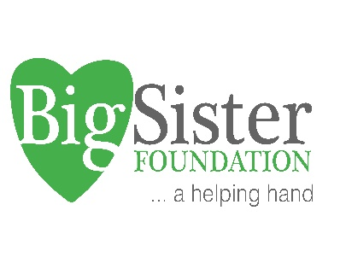
BIG SISTER FOUNDATION 2022 COMMUNITY GRANT

Applicant Declaration Form

This Applicant Declaration must be made by one of your organisation's authorised signatories.
Your nominated authorised signatory will also be responsible for signing the Letter of Engagement (Contract).

Title
First Name
Last Name
Position
Email
Please tick below to indicate you agree to the Applicant declaration:
I have read and agree to the requirements for eligibility and participation Guidelines. • I certify that the information in this application is true and correct. • I agree that if this submission is successful in receiving grant funding, details about the project may be used by Big Sister Foundation for evaluation and promotional purposes.

I agree to the above declaration: ☐

Signature: ………………………………………… Date …………….

